1. Create a vm in azure in a resource group
2. Create a application a gateway select those who develop vm attached that
3. Then as a backend pool
4. After installing that pool
5. With the my domain name that application will search
6. For that purpose we have to do
7. We go -- C:\Windows\System32\drivers\etc
8. And change the hosts file
9. 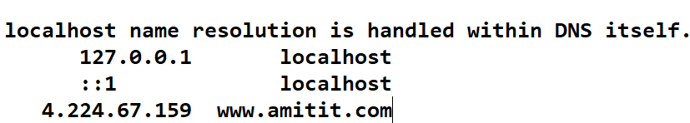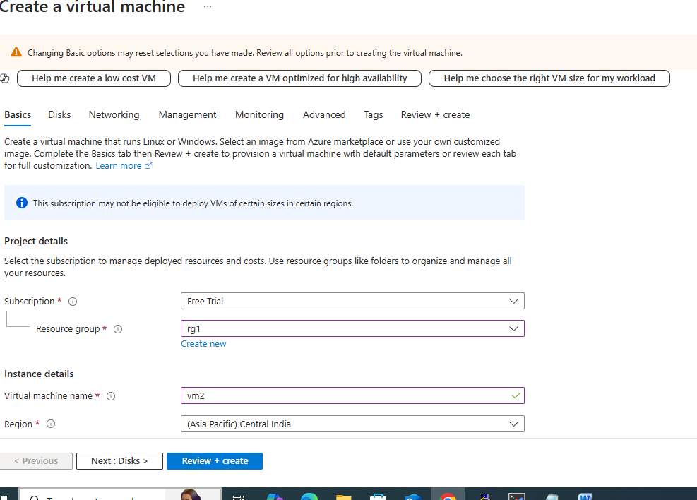
10. 